**Learner Details**

* **Name:Nikhil k**
* **Enrollment Number: su625mr004**
* **Batch / Class: Mern Stack**
* **Assignment: Resume**
* **Date of Submission: 04-07-2025**

**Problem Solving Activity 1.1**

**1. Program Statement**

Create a simple HTML-based personal resume webpage displaying personal details, educational qualifications, skills, and projects, using basic HTML elements for structure and formatting.

**2. Algorithm**

• Start with the HTML document structure (<!DOCTYPE html>, <html>, <head>, <body>).

• Add name, address, and contact details at the top using headings and anchor tags.

• Create an "Objective" section using headings and paragraph tags.

• Display "Education Qualification" in a table with columns for degree, institution, year of passing, and percentage/CGPA.

• List "Skills" using an unordered list.

• Add "Projects" as a list with brief descriptions and technologies used.

**3. Pseudocode**

START

DEFINE HTML document with head and body

DISPLAY personal details in center

SHOW objective section with paragraphs

CREATE table for education qualifications

LIST skills using unordered list

LIST projects with descriptions and tech stack

END

**4. Program Code**

<!DOCTYPE html>

<html lang="en">

<head>

    <meta charset="UTF-8">

    <meta name="viewport" content="width=device-width, initial-scale=1.0">

    <title>Document</title>

</head>

<body>

    <center><h1>NIKHIL K</h1></center>

    <center><h4>Yelachenahalli, Banglore 560078</h4></center>

    <center><a href="tel:+919380085115">+91-9380085115</a></center>

    <center><a href="https://github.com/Nik5codes">https://github.com/Nik5codes</a></center>

    <center><a href="mailto:nikhilkunjathaya5@gmail.com">Email:nikhilkunjathaya5@gmail.com</a></center>

    <u><h2>Objective</h2></u>

    <p>To work in a challenging environment that enhances my skills and knowledge.</p>

    <p>To work in a company that provides me with the opportunity to improve my skills and knowledge to grow along with the organization.</p>

    <hr>

    <u><h2>Education qualification</h2></u>

    <table border="1" cellpadding="10" cellspacing="0" Width="100%">

        <tr>

            <th>Degree</th>

            <th>Institution</th>

            <th>Year of Passing</th>

            <th>Percentage</th>

        </tr>

        <tr>

            <td>MCA</td>

            <td>Dayananda sagar college of Engineering</td>

            <td>2025</td>

            <td>8.17CGPA</td>

        </tr>

        <tr>

            <td>Bsc Electronics</td>

            <td>Vivekananda degree college</td>

            <td>2019</td>

            <td>7.8CGPA</td>

        </tr>

        <tr>

            <td>PCMCs</td>

            <td>Ambika P U college</td>

            <td>2017</td>

            <td>67.83%</td>

        </tr>

    </table>

    <hr>

    <u><h2>Skills</h2></u>

    <ul>

        <li>C</li>

        <li>C++</li>

        <li>Python</li>

        <li>Java</li>

        <li>HTML, CSS</li>

        <li>SQL, PL/SQL</li>

        <li>Git</li>

        <li>React</li>

    </ul>

    <hr>

    <u><h2>Projects</h2></u>

    <ul>

    <li>

        <strong>Intern, Gonagoor Technology Solutions</strong> (Nov 2024 – Jan 2025)<br>

        Contributed to mobile app development using React Native, Firebase, and Python. Worked on feature implementation, bug fixes, and performance improvements in an Agile environment.<br>

        <em>Technologies used:</em> React Native, Firebase, Python

    </li>

    <li>

        <strong>NMMS Initiative & Grantha Mithra Program</strong><br>

        Supported NMMS exam prep by enhancing an educational website and mentoring rural students in academics and personal development through library programs.<br>

        <em>Technologies used:</em> HTML, CSS, JavaScript

    </li>

    </ul>

</body>

</html>

**5. Test Cases**

| **Scenario** | **Expected Result** |
| --- | --- |
| **Page loads in browser** | **Name, contact info, objectives, education, skills, and projects are visible** |
| **Click phone link** | **Opens dialer with number** |
| **Click GitHub link** | **Opens GitHub profile in browser** |
| **Click email link** | **Opens default email client with recipient filled** |

**6. Screenshots of Output**

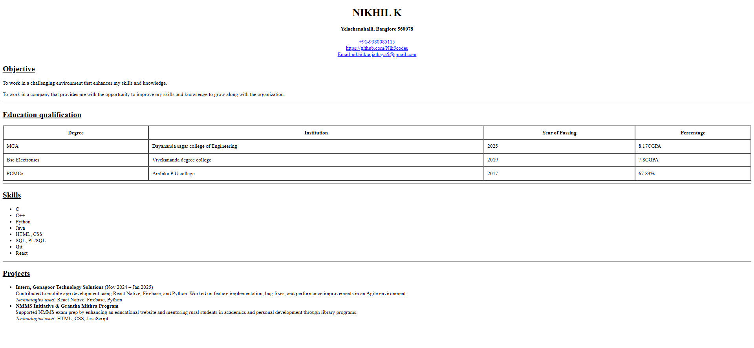

**7. Observation / Reflection**

• I learned how to structure a resume page using only HTML tags like <table>, <ul>, <h1>, and <p>.

• I realized <center> works but should be replaced with CSS for modern layouts.

• Next time, I will use CSS to make the design responsive and more visually appealing.